**Economic Moats Explained: How Businesses Defend Their Market Dominance**

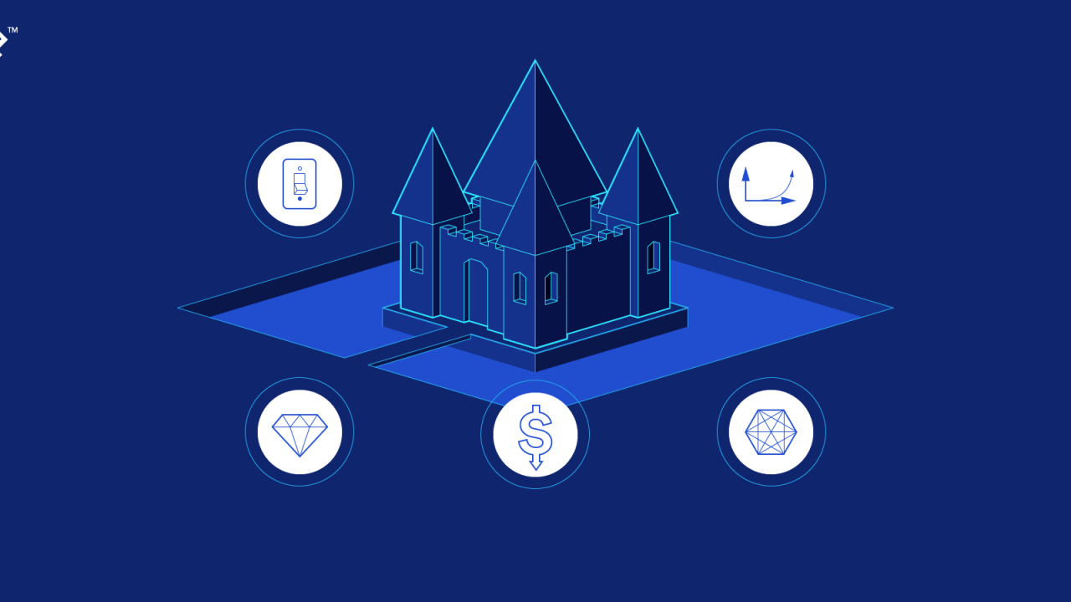

**What is an Economic Moat?**

* The term “**economic moat**” refers to **a long-term competitive advantage** that a company holds that **protects its position** in the marketplace.
* A company with a **strong moat** possesses a competitive advantage that is both **strong and sustainable**.
* It's a competitive advantage that **prevents other players from stealing market share, sales, and consumers** from a company.
* Companies can create economic moats through **competitive pricing** and **keeping costs low**, by **establishing popular brands,** and through **intangible assets**.
* In effect, the moat **leads to sustainable profits** over the long run and a **more defensible market share**, as the advantage cannot be easily mimicked by others.
* Once companies capture a sizable percentage of a market, their **priorities** shift towards **profit protection** from outside threats such as **new entrants**.
* The **more difficult it is to switch** to a rival offering – either due to monetary reasons or convenience – **the stronger the moat**.

**What Benefits Do Economic Moats Provide?**

* The advantage can come from any of several things – **lower production costs, patents, high switching costs** – any one of which can be especially helpful in differentiating a company from its competitors and in retaining its customer base.
* Moats **protect the market share** and positioning of companies and facilitate the **long-term sustainability** of their business model, including the continued generation of profitability.

**What are the different Types of Moats in Business?**

* **Narrow Economic Moat:** A narrow economic moat refers to a **marginal competitive advantage** over the rest of the market. While technically still representing an advantage, these sorts of moats **tend to be short-lived**.
* **Wide Economic Moat**: A wide economic moat is a **competitive advantage** f**ar more sustainable** and difficult to compete with in terms of market share.

**How to Create an Economic Moat?**

* **Production advantages**:

A company achieves production advantages when it can provide a service at a **lower cost** than that of its competitors.

Some common features of production advantages are:

1. **Complexity**: Processes that are **unique** and **difficult to imitate** are good moats, as they tend to be durable.
2. **Protection**: A company’s products can be protected through **patents, copyrights, trademarks, or operating rights**.
3. **Economies of Scale:** The cost of production on a **per-unit basis declines** as the company **expands in scale** (e.g. Amazon, Walmart).

* **Consumer advantages**

A company achieves consumer advantages when it can provide a **greater benefit** to consumers than its competitors do.

Some common features of Consumer advantages are:

1. **Habit and horizontal differentiation**: When customers **prefer a product to other** competing products, there is horizontal differentiation.
2. **Switching costs:** Switching costs are costs that a customer **must bear if they want to switch** to another product or service.
3. **Network effect**: The network effect occurs **when the value for the company and existing customers increases** as more people use a service or product.

* **Brand value**

Brand value is the idea that a company can **generate more revenue** or **charge a premium price** because of brand recognition.

**How to build the moat in Business?**

* Identify the Strengths and Unique Selling Proposition (USP)
* Understand the Industry and Competitive Landscape
* Assess Existing Moats
* Strategies for Building Moats
* Monitor and adapt
* Communicate Business's Moat
* Track Performance and Measure Success

**What is a Real-Life Example of an Economic Moat?**

For instance, **Apple** is a clear example of a company with an **economic moat** from various sources.

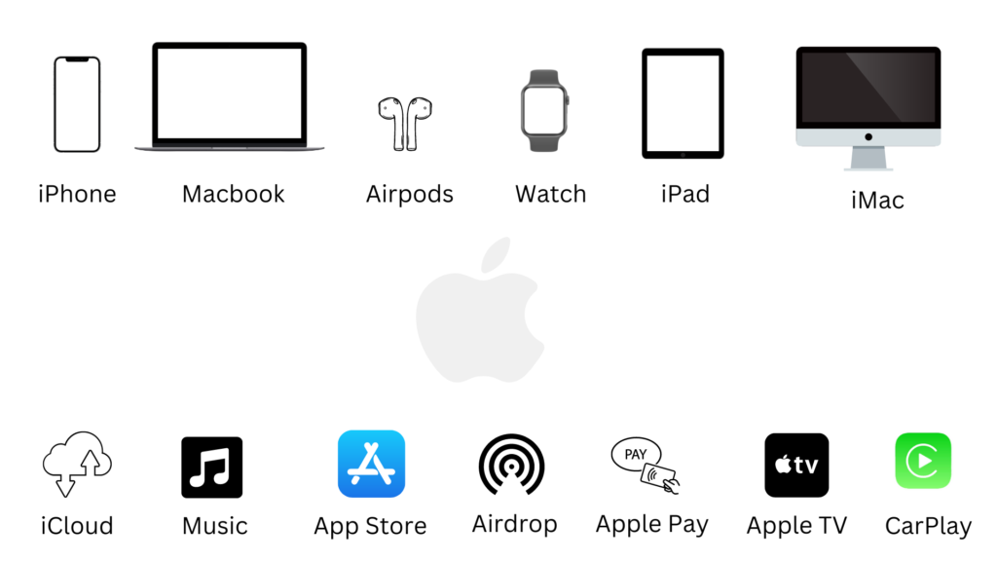

Image 1: Apple Ecosystem

For Apple, not only is it **expensive** for customers to **switch to a different product** offering, but it is **difficult to escape** the so-called “**Apple Ecosystem**”.

Learning from Apple’s Success:

1. Cohesive experience across devices
2. Observe what the user is trying to do
3. Multiply the overall value as compared to the value of each device
4. Customer loyalty and brand value
5. Make users productive by saving time
6. Don’t just focus on selling individual devices

Bottom of Form